Software Design Document
Deep Packet Intelligence


Submitted by
Muhammad Saeed
Roll No:
S23BINFT1M01193
Submitted to
Dr. Dost Muhammad Khan

Department of Information Technology
Faculty of Computing
The Islamia University of Bahawalpur

Summary
In this Software Design Document (SDD), a detailed design and implementation of Deep Packet Intelligence System is presented that was created as a Final Year Project in the Department of Information Technology at The Islamia University of Bahawalpur. This document describes the background information about the project, the general design of the system, the proposed system architecture, database design and user interface design.
DEEP packet intelligence module filters real-time continuous network traffic for analysis through packet inspection, training and statistical flow analysis, machine learning and signature based detection techniques. The system is able to collect packets from live network interfaces or uploaded PCAP (packet capture) files, analyze traffic flows, detect protocols, derive network characteristics, and raise alerts for suspicious and malicious traffic.
The application is designed as per Model-View-Controller (MVC) architecture to make it modular, maintainable and separate the backend/implementation from the frontend visualization of the application. The system's backend is built with Python, Fastapi, Scapy, Tensorflow, Redis, and Postgres and the dashboard is developed using react.js and chart.js with realtime monitoring and interactive data visualization.
This document also outlines database entities, relationships, screens and security aspects of the user interface, software components, controllers, API's, strategies for testing, and deployment structure of the system. The proposed DPI system is proposed to provide an efficient, scalable, and intelligent platform for traffic detection, anomaly detection and cybersecurity analysis.

Table of Contents
Summary .................................................................................................................. 2
1. Application Architecture ...................................................................................... 4
1.1 Architectural Pattern (MVC) .......................................................................... 4
1.2 System Layers ................................................................................................ 5
1.3 Models ............................................................................................................ 5
1.4 Views ...............................................................................................................6
1.5 Controllers ......................................................................................................6
1.6 External APIs and Libraries ............................................................................6
1.7 Technology Stack ............................................................................................7
1.8 Security Considerations ..................................................................................7
1.9 Coding Conventions .......................................................................................7
2. Data Model Schema .............................................................................................8
2.1 Entity: Flows ..................................................................................................8
2.2 Entity: Alerts ..................................................................................................9
2.3 Entity: Packets .............................................................................................. 9
2.4 Entity: Rules ................................................................................................. 9
2.5 Entity: Users .................................................................................................10
2.6 Relationships Summary ............................................................................... 10
3. User Interface ....................................................................................................11
3.1 Design Philosophy .......................................................................................11
3.3 Screen 0: Login Screen ............................................................................... 12
3.4 Screen 1: Live Monitor ................................................................................13
3.5 Screen 2: Flow Explorer ..............................................................................14
3.6 Screen 3: Alert Console ...............................................................................15
3.7 Screen 4: Protocol Statistics ........................................................................15
3.8 Screen 5: PCAP Analyzer ...........................................................................16

1.Application Architecture
The architecture of the Deep Packet Intelligence (DPI) system will be scalable, modular and efficient and will create a potent platform for analyzing network traffic in real time and for tracking cyber security risks. It is developed using multi-layered architecture and also possibly implementing the Model View Controller (MVC) pattern to help minimize the amount of domain logic, View logic and Data logic.
The architecture has several layers like packet capturing, traffic processing, analysis engine, backend API services, database storage and visualization on the frontend. Packets from the packet capture layer are being captured with Scapy, a live capture or from a PCAP file. Only machine learning and the signature-based approach are used in the processing and the analysis layer for decoding/encoding of the packets and generation/detection of the flow, identification of the protocol.
There are Core operations and data manipulation performed using FastAPI, the API is then communicated with back-end services.APIs are used to interact with the backend services and to manipulate the data and are handled with FastAPI. Ten creates it has a balanced storage system – that means if you wish to store some of your data with structure, it gets stored atop in PostgreSQL, but should you wish to store some of your data as soon, as you could apply it, it gets stored atop in Redis (which is store, and has fasted data storage).
Two libraries like React.js and Chart.js are used to build the front end application's dashboard, ready to display traffic stats, alerts and network traffic interactively. The entire architecture should be very effective, modular, maintainable and secure throughout the system for communicating.

1.1 Architectural Pattern (MVC)
The Deep Packet Intelligence (DPI) system is designed and implemented based on the Modular-View-Controller (MVC) paradigm which facilitates modular and scalable design, and makes the system easy to maintain. Along with the MVC comes the development of the application in three parts: Model, View and Controller. The system data and Database are managed by the model, the client interface is the view and the controller is responsible for passing messages between the view and the Functions used for Services. This segregation helps in easy maintenance and upgrading of the system and is useful in the organisation of the code. Additionally, the pattern for MVP allows flexibility of coding both in frontend and backend, since these might be specific requirements for cyber security monitoring and traffic analysis; therefore, it will make the application flexible and efficient when required.

1.2 System Layers
The DPI system consists of several layers (tiers), to spread out the responsibilities among them and to increase effectiveness of this system. The packet capture layer supports both live packets and PCAP files to be captured from using Scapy. A processing layer is used to extract the features from the packets, to filter and decode it. Anomaly detection, flow generation, protocol detection, machine-learning analysis are among the processing task of the analysis layer. An intermediate API layer was created with FastAPI which enables the integration between the components, and receives requests from the front end dashboard. Data storage with the databases PostgreSQL and Redis is used for very short-term holding and for applying it in realtime. In the last place, presentation layer offers the user a graphical visualization and monitoring, and achieved with the dashboard developed using React.js.
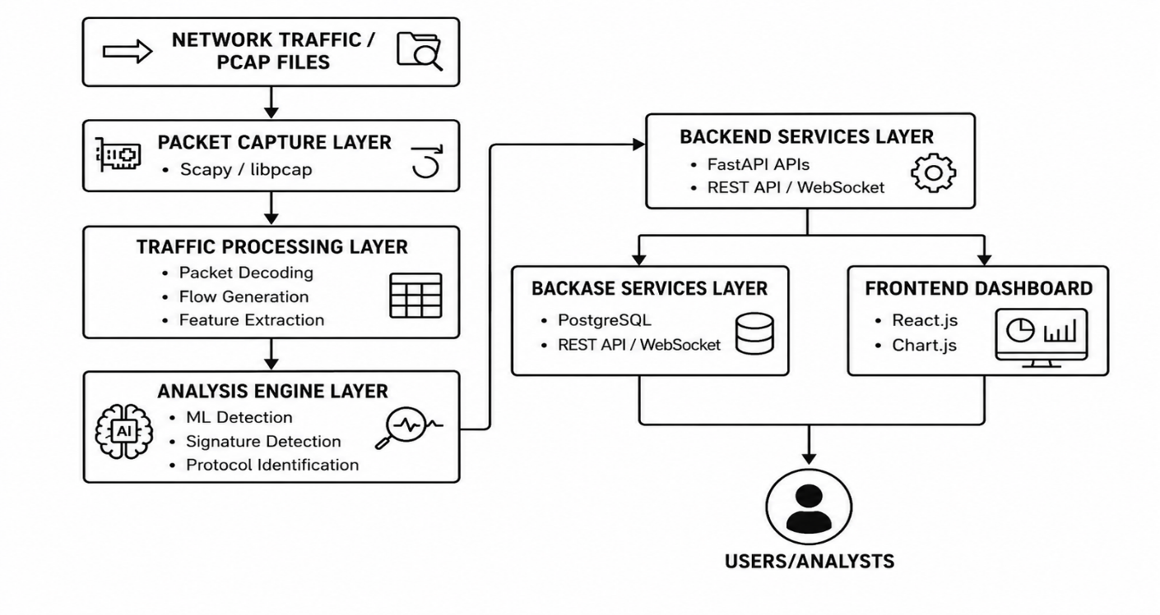

1.3 Models
The Model are a representation of data structure and business logic of the DPI system. These are responsible for information and packets, flows, alerts, users, protocols etc. being stored & handled within the database. Unlike the previous setup of models communicating with other services, the models are now communicating directly with postgresql, allowing them to perform actions such as inserting, updating, deleting and retrieving data. They also provide uniformity in data and relationships between objects differing from each other. This is done by adding an interface to the models, which processes and analyzes network data as it is produced, and can cope with a huge amount of network data produced by the DPI engine.

1.4 Views
Views: It is the user interface that will show the information to the user in a graphical (visual) way, in the front end of the application. The views are designed using React.js, and feature such screens as the Login Screen, Live Monitor, Flow Explorer, Alert Console, Protocol Statistics and PCAP Analyzer. These interfaces show interactive graphs and tables for the statistics, alerts, charts
and packet information used in the network. All data from the Backend APIs is continually refreshed and can be sent to views without refreshing the web page.

1.5 Controllers
The MVC system involves controller which works as a mediator between the front end – views & back end – models. They accept user requests, relate with models and deliver user interface with the appropriate answers. Controllers are generated/initiated by the DPI web APIs within FastAPI, which are used to handle logon authentication, handle packet requests, and pull reports of alerts data and/or filter data and updates DPI dashboards. Additionally, controllers can guarantee proper formatting of user input, ensure security policies are met and create communication between the different parts of the system, ensuring that it operated smoothly.

1.6 External APIs and libraries.
Several external APIs, as well as libraries, are being used in the Deep Packet Intelligence system to support packet capture, traffic analysis, machine learning and real-time visualization. For network packet capture, libpcap/Npcap is used to capture live traffic from network interfaces, and to process PCAP files. Implementation of backend analysis is done in Python using Scapy to parse and decode packets and protocols. They use libraries like NumPy and Pandas for data processing and statistical analysis and Scikit-learn for traffic classification and anomaly detection through machine learning techniques. This system backend is implemented with FastAPI, providing RESTful APIs for communication between the system components. PostgreSQL is used with appropriate database drivers for data storage and management. In front end, React.js is used to develop the interactive dashboard and Chart.js is used to represent the network statistic graphically and in real-time for traffic visualization.

1.7 Technology Stack
The Deep Packet Intelligence System is built from scratch on a state-of-the-art, full stack architecture, which includes a network packet analytic layer, machine learning layer, the back end, and interactive visualization. The backend is written in Python with the use of FastAPI for creating RESTful APIs and Scapy for capturing and analysing packets and protocols. A machine learning based approach to detecting traffic and traffic anomaly detection is done using Scikit-learn and TensorFlow. For data storage and management, PostgreSQL is used; Redis is used for caching and
for dealing with real-time data. Front-end: We use React.js to build the web based dashboard, and Chart.js is employed for visual representation of real-time network traffic and statistics. It runs on a Linux like environment, and uses low-level packet capture library libpcap/Npcap for interfaces and PCap files.

1.8 Security Considerations
Security mechanisms are part of the Deep Packet Intelligence System that safeguards the operations of the system and users' information. To secure the system against unauthorized access, authentication and access control is employed and secure communication via API and input validation is used to minimize typical security vulnerabilities. Securing data and good error-handling also are added to systems to improve reliability and safety.

1.9 Coding Conventions
System conforms to standard coding conventions so as to improve the code readability and consistency. Developed according to PEP 8, the Python code has been written; for the frontend, a set of structured React.js components has been provided. The project employs meaningful variable
names, proper indentation, comments and modular programming techniques throughout to make this project easier to maintain and expand.

2. Data Model Schema
The Deep Packet Intelligence System employs a relational database schema for storing and managing all the network traffic information generated upon packet inspection and analysis. Supports real-time monitoring, back analysis, anomaly detection and forensic investigations.
Flows is the main entity that hosts the details about the communication between nodes (either devices or humans). The Alerts entity captures security alerts that arise from machine learning models and signatures. This is the Packets entity that holds packet level data from samples for detailed inspection and troubleshooting. Other entities (such as Rules) deal with detection and Users with authentication and system access.
The schema is realized in PostgreSQL using indexing of the fields, constraints, foreign keys and primary keys, which guarantee the speed of the queries and integrity of the data. Relationship between tables allows the correlation of alerts to flows and packets to sessions to enable analysis of these logs to a higher level.

2.1 Entity: Flows
The Flows entity is at the heart of the Deep Packet Intelligence system, and contains full flow data for all communications sessions between two endpoints. This contains the following important columns: source IP address, destination IP address, source port number, destination port number, protocol used (tcp/udp/icmp), start time of the session, end time of the session, total duration of the session, and the total number of bytes sent. This is an important aspect to understand data traversing the network and uncovering normal and abnormal traffic patterns. It includes support for grouping packets into logical flows, which also aids in session recognition, bandwidth analysis and anomaly detection. Alerts and packets can be coupled to each flow to investigate it in greater depth. The Flows entity has numerous data indexes making it convenient to manage query and fast retrieval on dashboards, reporting and security analysis in the DPI system.

2.2 Entity: Alerts
This entity is used to store all the alerts raised by the Deep Packet Intelligence system in case of suspicious or malicious activity. Each alert record includes details like description of the discovered threat, detection method (signature or machine learning), severity, alert ID, and a detection time. It also contains a foreign key reference to the correlated network flow which can be used to trace the network flow through which the alert occurred. This entity is important in intrusion detection system, anomaly-reporting and real-time threat monitoring. Alerts may be triggered for any kind of events: port scanning, DDoS behavior, odd volume of traffic, protocol violations, etc. This entity is the core of dashboards, notifications and forensic investigation by security analysts within the system.

2.3 Entity: Packets
The Packets entity stores network packet information in great amount of detail, collected during traffic monitoring and inspection, on very low level. This contains the packet's identification number, the time that the packet was captured, the size of the packet, the Ethernet, IP and TCP/UDP headers, the source address and the destination address, along with a summary of the payload section that provides analysis information. Packets give granular visibility of each individual unit of data moving over the network, unlike Flows which represent sessions. This entity is essential for a deep packet inspection, debugging of network problems and forensic analysis of network security incidents. Packets may be matched to some flows, from which the entire communication session may be recreated from the raw data on a system. This large amount of packet data is optimized by combining indexing and sampling methods to allow for efficient storage and fast retrieval without impacting on system performance.

2.4 Entity: Rules
On the other hand, the Rules entity describes the rules (including detection logic and security policies) that are applied to identify abnormal network behavior and malicious network traffic by the Deep Packet Intelligence system. The rules contain a Rule ID, the RuleName, the type (signature or behavioral), the conditions/expressions, and the Action to be performed if a match occurs. These actions can involve triggering an alert, blocking traffic or recording the event for later review. Rules are a critical component of the system that allow for the system to be tailored to reflect the security needs of the organization and the threats to which it’s exposed. They enable administrators to specify warning patterns like unexpected port use, large amounts of traffic or known attack signatures. The Rules entity works closely with the Alerts and Flows entities to enforce real-time security decisions. Periodically updated to stay current with current threats and enhance the precision of intrusion detection in the system.

2.5 Entity: Users
The Users entity has information on the users of the Deep Packet Intelligence system. It includes user ID, username, e-mail, password hash, Job Role and Account Status. This entity is used for authentication, as well as authorization, meaning that only people with authorization to use features would be able to use the features. Level of access and permissions depend on the type of role: admin, analyst or viewer. It also logs on activity for security auditing purposes. The Users entity is used for access control, accountable management and security of the traffic and analysis data of the network.

2.6 Relationships Summary
All of the major components of the DPI system are then related through the database relationships. A central entity in Flows are connected with Packets and Alerts to analyze them in detail. Alerts are created by flow behavior and rule matching; while Packets are part of specific flows. The Rules entity specifies the conditions for detections that cause alerts. Users work with rules and view alerts via the system. These relationships ensure data consistency, deliver efficient query operations and allow monitoring and forensic analysis throughout the system in real time.
3. User Interface
The User Interface (UI) of the Deep Packet Intelligence (DPI) system provides a user-friendly and real-time webpage interface to view and examine network traffic. It allows a display of the packets as they come in, enables the user to see the packets' flow on an organized display, dissects the protocols, and arranges and manages security alarms on an organized dashboard. It is a modular-based and component-based system created using the framework named React.js in order to be flexible and maintainable. Chart.js is used to visualize, show the statistics of the network such as traffic, protocol distribution and anomaly detection results in a graphical format.
It will be a ‘Model-View-Controller (MVC)' system: Model will be structured data which is passed from Back End, Controller will be responsible for Communicating with API whilst View will be the Front End interfaces. Thus, more scalability and maintainability is achieved.
The interface also offers live updates without needing to refresh the pages, enabling you to monitor network activity in real-time. It features various screens, such as live monitoring, flow analysis, packet inspection and alerts. Overall the UI makes cyber security analysis as easy and effective as it can be.

3.1 Design Philosophy
Modularity, scalability and real time analysis of traffic is the paradigm on which the Deep Packet Intelligence (DPI) system is designed. Built out of layers to make the system easily maintained and flexible, with four levels: packet capture is at the bottom, processing is at the intermediate level, analysis is also at the intermediate level, and visualization is at the top. Applies the separation of concerns – each module has one specific function and is independent.
The system can be able to observe the network traffic continuously with minimal “latency.” They are using PostgreSQL and Redis for speed of data access and near real time processing. Security also plays an important factor in the design, such as user authentication and authorization based on roles.
The separation of the backend, front-end, and the data management operations takes place in the DPI system, with the help of the Model-View-Controller (MVC) architecture. The overall efficiency of the design, ease of maintenance and reliability in engineering a cyber security veillance.
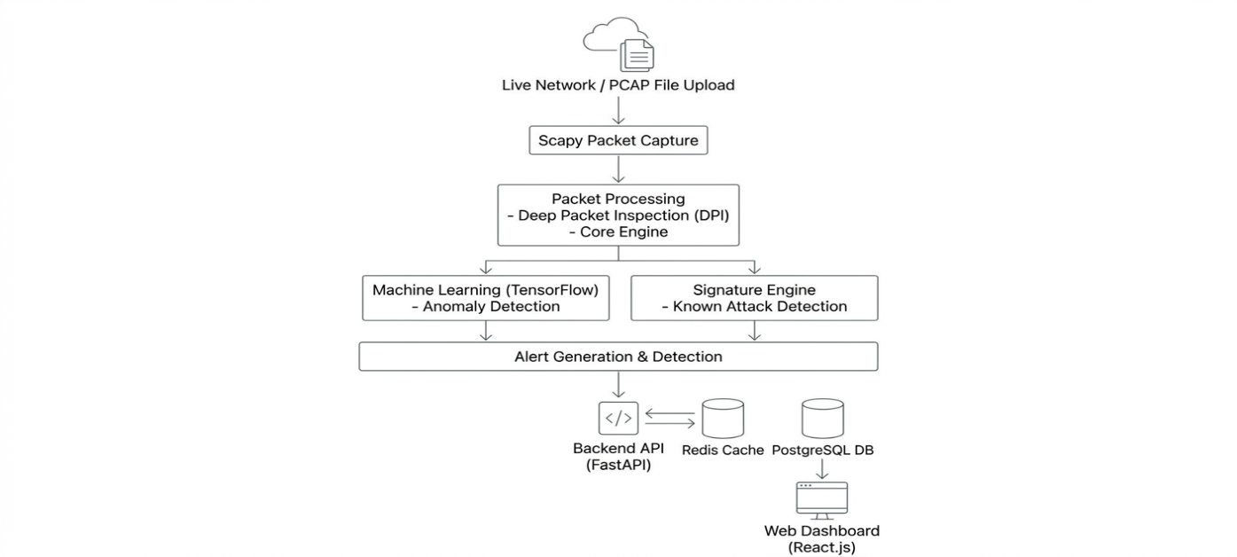

3.2 Screen 0: Login Screen
The Login Screen of the Deep Packet Intelligence (DPI) system will be the first screen to be presented to the user who accesses the system and will serve to authenticate the user before offering him/her community-based access to the Dashboard. It offers a secure interface to the system, at which the user enters their username and e-mail and enters their password. The layout of the screen is simple and easy to use, allowing for easy access to the information and intuitive navigation.
The login module provides secure authentication methods, such as secure password verification, and even token per session management. Access is also limited by role based access – the user is an administrator, analyst or viewer.
If bad ID's are entered into the system, the system alerts the user to the fact that the ID's are wrong. Once users successfully log-in they are redirected to the main dashboard. The login screen guarantees safe, monitored access to important network monitoring and analysis capabilities of the DPI system.
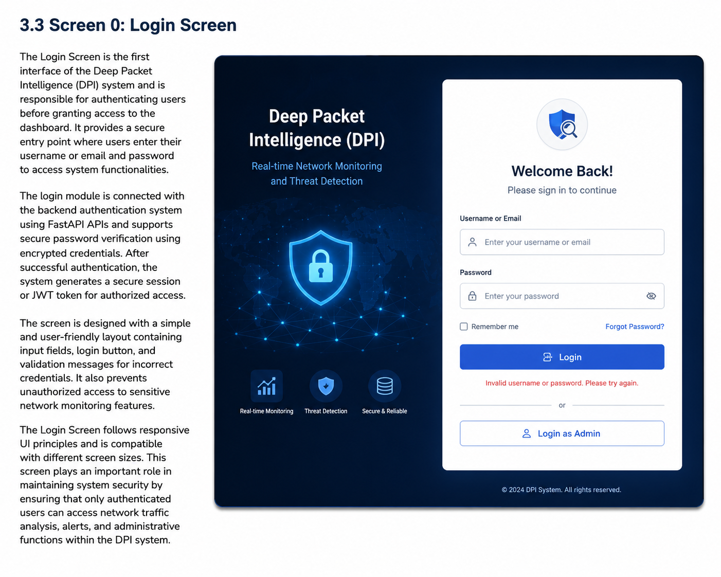

3.3 Screen 1: Live Monitor
Live Monitor screen is the main dashboard of Deep Packet Intelligence (DPI) system which visualizes the activity of the network traffic in real time. This screen shows packets that are coming in and going out of live network interfaces, so that users can see how the network acts as they are looking. The aim is to provide cyber security analysts with visibility about traffic flow, identify abnormal traffic and warn them of potential threats in real-time.
Network activity is clearly presented in an understandable format with interactive charts and graphs, traffic statistics, such as packets, Bandwidth, active flows, protocol distribution, alert notifications etc. The Live Monitor can also be used to detect unusual traffic flows and displays alerts that have been triggered for unusual traffic detected by the machine learning or signature-based detection engine.
The interface does not require any refresh when updating, it updates in real-time automatically. Users can customize the traffic data they want to view by using a filter to choose a protocol, an IP address or a port. Overall, the Live Monitor screen provides a user-friendly and comprehensive interface for real-time monitoring and security analysis of the network.
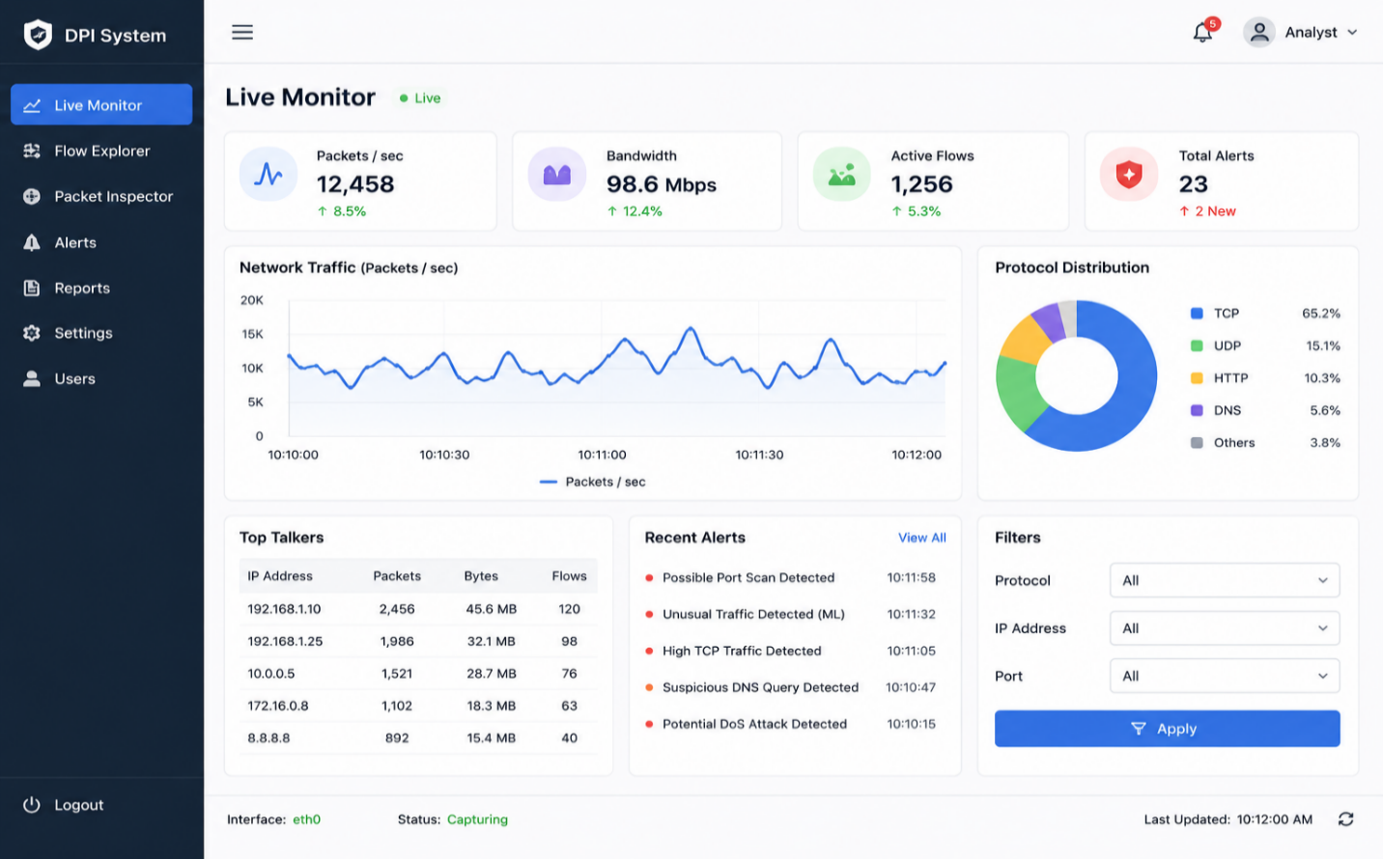

3.4 Screen 2: Flow Explorer
The Flow Explorer screen is meant to show and analyze the network traffic flows produced from captured packets in the Deep Packet Intelligence (DPI) system. A network flow consists of series of packets which have the same characteristics (IP source, IP destination, ports, protocol type, etc.). This screen helps cyber security analysts better comprehend the communications and traffic activity.
Flow Explorer shows records of flows in a tabular format in a structured way using all the significant fields, like source and/or destination address, protocol type, number of packets, byte statistics, flow duration and flow traffic status. Users have the ability to search, sort and filter flow records by either IP address, protocol, port number or timespan which enables users to analyse the traffic efficiently.
The screen also can detect communication patterns that may be suspicious or unusual, such as an abnormal or suspicious flow detected by the machine learning or signature-based detection engine. Real-time updates allows the ability to monitor real time as the flow occurs without refreshing the interface.
In conclusion, the Flow Explorer offers a comprehensive and structured platform for exploring network flows and conducting cybersecurity analysis.

3.5 Screen 3: Alert Console
Alert Console screen allows you to view and handle security alerts generated by the Deep Packet Intelligence (DPI) system. Provides real-time signals to cybersecurity analysts about unusual, suspicious or malicious network activity that's identified by machine learning or signature based detection techniques.
Alerts are presented on the screen in an orderly and organized manner, including type of alert, severity level, source and destination IP address, protocol information, alert time, and alert time (time of detection). In general, there are some alerts ranging from low, medium and high, for the analysts to prioritize the threats properly.
The Alert Console will stay on the same page without refreshing with the latest alerts, so that new threats will appear on the Dashboard as they get detected. Users can also view the severity levels of users' alerts, protocols, IP address(s) and time range to help them investigate.
In addition to this interface, analysts can view of the alert details, acknowledge alerts and monitor any potentially suspicious activities as they happen. The Alert Console is typically used to provide a single location/centre to watch threats, act on incidents and manage security events in the DPI system.

3.6 Screen 4: Protocol Statistics
The Protocol Statistics screen displays detailed visualization and analysis of network protocols that the Deep Packet Intelligence (DPI) system detects. It's used mainly as a way to understand traffic distribution and behaviour of different protocols. It chooses to decode the packets without missing them and it classifies them into protocols (e.g. TCP, UDP, HTTP, DNS, FTP, SMTP etc.).
Interactive charts, graphs and statistical summaries of the information are available on the screen. Shows protocol usage, percentage, number of packets used, bandwidth usage, active sessions and the trend of traffic over time. These visualisations allow analysts to easily observe the proportions of the most used protocols, startling communications, etc.
It is also simple to detect unexpected network data traffic types in the Protocol Statistics screen by verifying whether any unexpected amounts of traffic occur by any protocol that might be incompatible with normal network traffic and could be an abnormal traffic. Real-time updates ensures the statistics are always up-to-date with actual network traffic.
Users can choose to view traffic data for a particular period of time, protocol type or traffic volume for detailed analysis. Finally, it is important to recognize that this screen provides a clear and intuitive view of protocols being monitored, as well as an assessment of network traffic.

3.7 Screen 5: PCAP Analyzer
In Deep Packet Intelligence (DPI) system the PCAP Analyzer screen is designed for offline packet capture (PCAP) file analysis. It also allows downloading the network traffic files already recorded to be subject to detailed analysis and checked for security. This feature may be useful in a forensic examination, traffic or during any investigation where there might be some unusual results that could not be detected at the time of actual examination.
After the PCAP is loaded, the “key” data for the packets captured is analyzed, resulting in such key data as number of packets, ports, protocols, flow statistics, source-to-destination IP address. The analyzer also detects abnormal traffic patterns, suspicious communication and protocol behavior via machine learning and signature-based detection technologies.
Analysis results are visually displayed on the screen in the form of tables, charts and packet summaries for easier traffic analysis. Users can search and filter the packets by protocol type, IP Address or time sequence with detailed analysis.
To sum up, the PCAP Analyzer provides a structured and easy-to-use environment for offline network traffic analysis, allowing cybersecurity analysts to examine a network event and perform thorough security evaluations.

